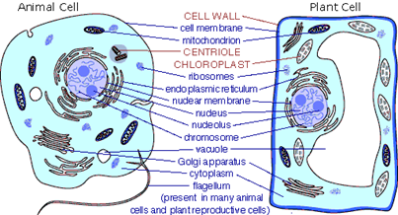
INTRODUCTION:
Cells are complex systems that contain various specialized substructures known as organelles. These organelles are “specialized” because each of them perform a different function that each contributes to keeping the cell in balance, or homeostasis. In other words, think of them as workers along an assembly line, each responsible for a single task to build the product of homeostasis. Without these various organelles, cells would not be able to carry out important chemical processes such as providing genetic information, producing energy, or assembling proteins.
Your home is also a system, whose operation also depends on various specialized components. In this exploration, you will relate the functions of organelles to the functions of household structures/items around you. For instance, lysosomes and peroxisomes in eukaryotic cells act like garbage disposals. Just as a disposal breaks down unwanted food and waste, lysosomes and peroxisomes contain digestive enzymes that break down toxic materials to get rid of.
LEARNING STANDARDS: Cells, Organelles, Prokaryotes/Eukaryotes, Animal/Plant Cells

PURPOSE: To relate the functions of organelles to the function of household structures/items.

ACTIVITY:
- Research the function of each of the organelles listed in the table below.

Use these websites to assist with research:
- http://www.biology4kids.com/files/cell_main.html
- https://www.pathwayz.org/Tree/Plain/ORGANELLES
- https://www.exploringnature.org/db/view/Cell-Organelles
- https://www.khanacademy.org/test-prep/mcat/cells/eukaryotic-cells/a/organelles-article

- Compare EACH organelle to a household structure/item that shares a similar function and take individual photos of those structures/items.

Each photo must include a slip of paper with your first and last name on it.
*See the lysosome/peroxisome example picture below.

- Justify how EACH household structure/item shares similar functions to the organelle it represents.

Each justification must include:
- A summary of the true function of the organelle in cells
- A description explaining how the household structure/item relates to the organelle
*See the lysosome/peroxisome example justification below.

Place your photos and write your justification in this table.
The Function of Organelles
Organelle Name | Household Structure/ Item Picture | Justification of Relationship
Nucleus
Cytoplasm/ Cytoskeleton
Cell Membrane
Cell Wall
Mitochondria
Chloroplast
Ribosomes
Endoplasmic Reticulum
Vacuole
Golgi apparatus
Flagella/Cilia
EXAMPLE:  Lysosomes/ Peroxisomes | 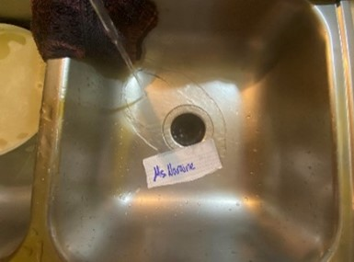 | Lysosomes and peroxisomes contain digestive enzymes that are responsible for breaking down and disposing cellular waste. This function is similar to the function of a garbage disposal because they are used to chop up waste into tiny pieces to be disposed of through the sink.

The Function of Organelles Scoring Rubric
Criteria | Beginning  (0-5) | Developing (6-10) | Proficient  (11-15) | Distinguished (16-20) | Score
Household Structure/  Item Picture | +5 photos are missing. No names in photos. Poor quality/blurry photos. | <5 photos are missing. Some names in photos. Some poor quality/blurry photos. | A couple photos are missing. A couple photos do not have name. A couple photos are poor quality/blurry. | All photos are there and all of them have name in it. No photos are poor quality/blurry. | /20
Justification of Relationship | +5 justifications are not properly written - the functions of organelles are incorrect and/or no description relating to household items. | <5 justifications are not written properly. | Most justifications are written properly, give or take a couple. | All justifications are written properly, and go beyond what is required. | /20
Document Organization - Neat? Late? | Document is not concise or consistent. Fonts are not the same. Photos are not properly sized. Document is late. | Document is somewhat concise and consistent. Some fonts are the same and some photos are sized. Document is on time. | Most of the document is concise and consistent. Most fonts are the same and most photos are sized. Document is on time. | The entire document is concise and consistent. Some extra creativity is present. Document is on time. | /20
 |  |  |  | Total Score = | /60

Additional Feedback:

